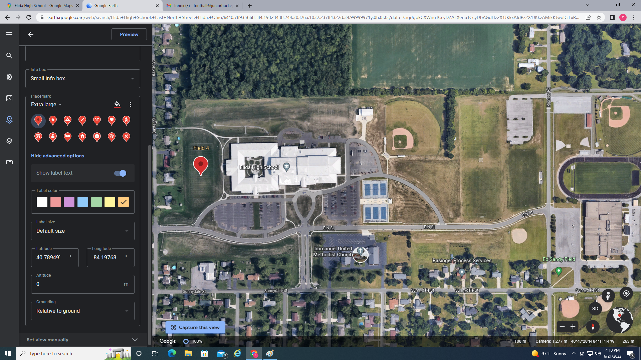
parking
Park
ing
Parking

park
park
Parking
Parking
Field #4
Scales
Field #1
Field #3
Field #2

